TPE TRAINING PEAKS AND DEVICE ORIENTATION
As an Elite Team applicant/member, YOU are responsible for your devices and your TrainingPeaks account, NOT your parent(s). We expect Elite Team members to behave with a high level of professionalism in managing these areas of their training – that includes troubleshooting when there are issues (and there will be issues). A list of troubleshooting links/suggestions are provided below for you.
Just a reminder that we expect TP to be fully updated at a minimum every 48 hours.

NECESSARY EQUIPMENT
- TrainingPeaks account and login information
- TrainingPeaks app on your phone is recommended, but not mandatory
- Garmin Connect account
- Garmin Connect app on your phone is recommended, but not mandatory
- Garmin watch with full sensor pairing capabilities and upload capabilities
- Heart rate monitor (chest strap, not wrist-based)
- Cadence sensor
- Power meter recommended, but not mandatory

SETTING UP YOUR DEVICE
- Download Garmin Connect app on your phone
- Create Garmin Connect account and register your device
  - Make sure Bluetooth is turned on for both your device and your phone
- Pairing sensors
- Run data fields
  - Indoor run – 1 screen, 3 fields:
    - Time
    - Heart rate
    - Cadence
  - Outdoor run – 1 screen, 4 fields:
    - Time
    - Heart rate
    - Cadence
    - Pace
- Bike data fields
  - Indoor/outdoor bike – 1 screen, 4 fields:
    - Time
    - Heart rate
    - Cadence
    - Power (preferred) or speed

SYNCING YOUR DEVICE TO TRAININGPEAKS
- On your laptop, login to both your TrainingPeaks and Garmin Connect accounts
- Go to: https://www.trainingpeaks.com/account/garminconnect
- Click the blue button that applies to you to sync
CHECKING AND UPDATING TRAINING PEAKS
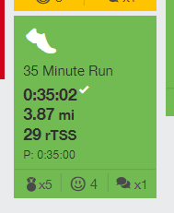
For ALL prescribed sessions – make sure they are GREEN if they were completed as assigned.
- Swim workouts checklist
  - Subjective feedback metrics (emoji and #/10 difficulty rating)
  - Time completed (do not depend on your device for this)
  - Main set(s)
  - Notable timed efforts
  - Written feedback regarding anything notable about the workout
- Bike workouts checklist
  - Subjective feedback metrics (emoji and #/10 difficulty rating)
  - Time completed
  - File uploaded* (should have HR, cadence, speed, and power if you have it)
  - Written feedback regarding anything notable about the workout
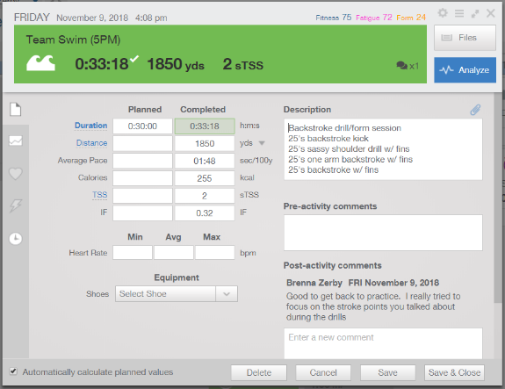
- Run workouts checklist
  - Subjective feedback metrics (emoji and #/10 difficulty rating)
  - Time completed
  - File uploaded* (should have HR, cadence, pace)
  - Written feedback regarding anything notable about the workout
- Strength/conditioning workouts checklist
  - Subjective feedback metrics (emoji and #/10 difficulty rating)
  - Time completed
  - General focus of the workout
  - Written feedback regarding anything notable about the workout
- Pre-hab/mobility sessions checklist
  - Time completed
  - Written feedback regarding anything notable about the workout
- Unassigned sessions checklist
  - You MUST include unplanned/unassigned workouts that you do
  - Workout title should have at the end (UNPLANNED)
  - There should not be a planned time (so workout should not be green or any other color)
  - Complete rest of checklist items according to the type of workout
*What do I do if I did not get a file for any reason? In this case, manually fill in as much info as you can – time completed, distance, etc. as well as a note in the comments about why you don’t have a file. Complete all other items as required.

A NOTE ON POWER METERS
Oftentimes your Garmin will give you the option to calibrate your power meter – always do this when recommended as these devices do sometimes require calibration, and incorrect readings can skew the training plan. Check out the website for your product to learn more about the details of calibration. If your meter ever seems to be giving abnormal readings, always calibrate before riding again.

POTENTIAL ISSUES/TROUBLESHOOTING
YOU are responsible for finding solutions when something is not updating/syncing/etc. the way it is supposed to – do NOT wait for your parents, coaches, or anyone else to figure it out for you. You have access to all the information you could possibly need via the internet, so work to find a solution even when it isn’t obvious.
- Sensor stops reading/won’t pair
  - First, try to re-pair the sensor
  - If it still won’t pick up, try installing a new battery
  - Note that heart rate chest straps work better when the portion under your chest is a little damp, so try wetting the strap just in that spot if your device is having trouble picking it up
- Files won’t load from device to Garmin Connect
  - Open the Garmin Connect app
  - Turn off Bluetooth on both watch and phone, turn off GC app, then turn Bluetooth back on and log back into the app
  - In rare cases you may need to completely re-pair your device to Garmin Connect to get files loading again
  - Oftentimes when files aren’t loading, the device may need to be updated, and files will not load until it has the chance to update
- Files won’t send from Garmin Connect to TrainingPeaks
  - Turn off auto-sync and then re-sync GC and TP
- Helpful links for troubleshooting
  - https://support.garmin.com/en-US/
  - https://help.trainingpeaks.com/hc/en-us
  - https://www.google.com

